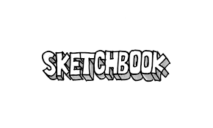

What is a sketchbook? How do I know if I am doing a **good** job? Why do artists use sketchbooks?

If you are asking these questions……. That’s great!

Let’s see what I can do to help answer them.

A sketchbook is a place to practice being an artist. 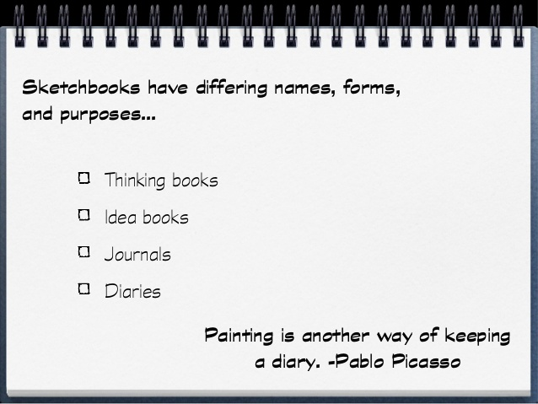Nothing needs to be perfect...But you should always try.

**When you Try… You Grow.**

Here is some examples of a sketch and a finished work of art. In the first one, the sketches are on top, and the finished illustration is on the bottom. In the rest, the sketches are on the left, and the finished art is on the right. These are professional’s work,, and I believe one day this could be you with practice!

1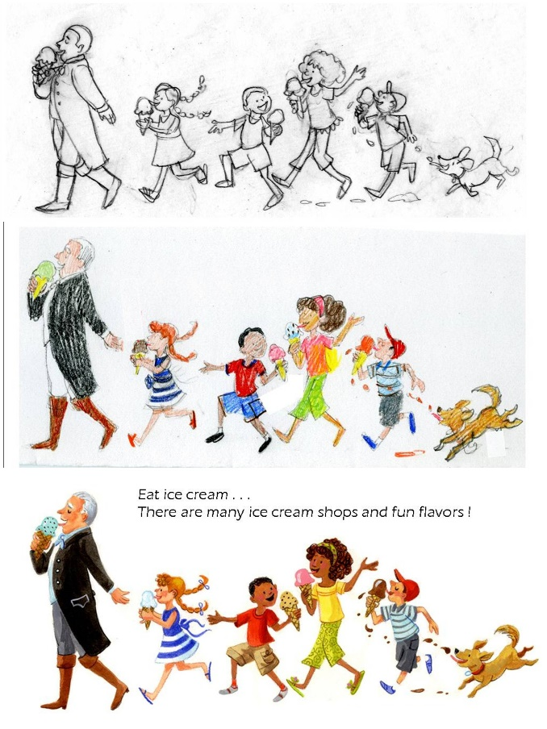

2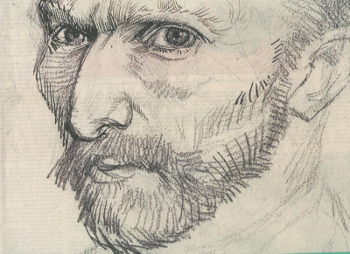 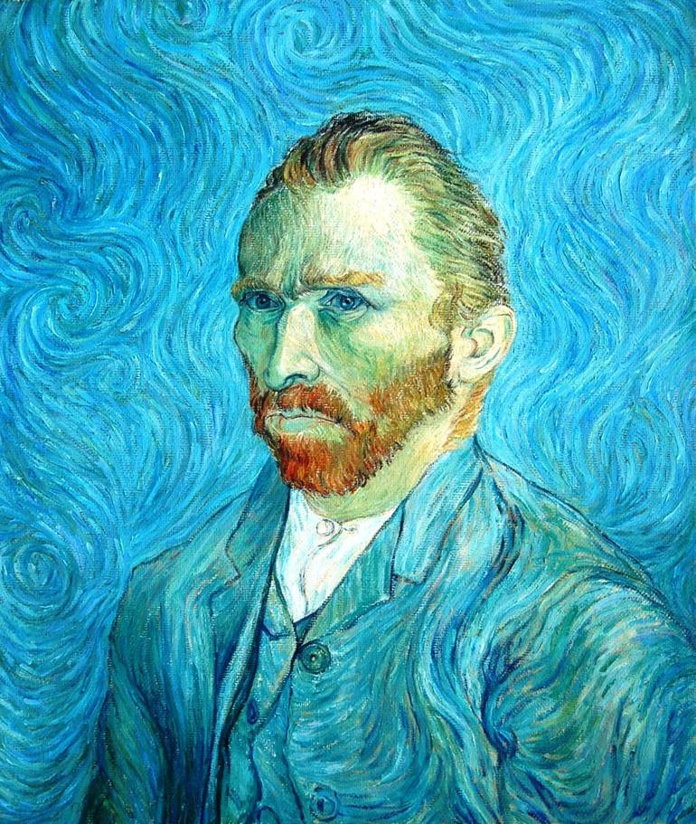

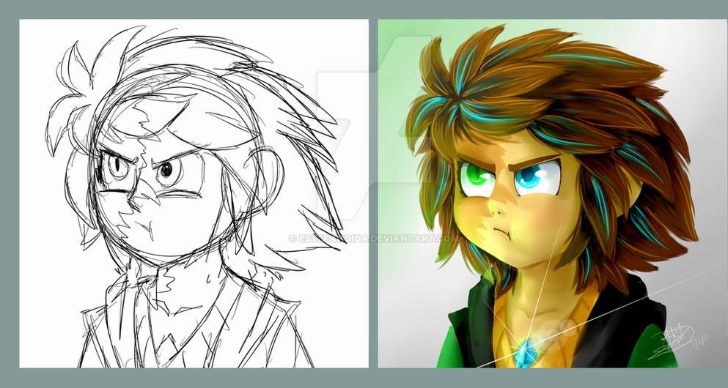

3

Sometimes artists use sketchbooks to figure out how to draw an object. They may draw the same thing again, and again, until they are happy with the results. They can fill pages with the same thing!

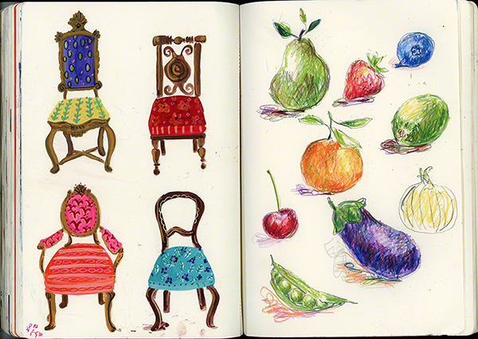

(Sketches can be in color in black and white, any material is acceptable.)

Sometimes sketches are words or ideas, or even notes! Artists jot down ideas to create later, dreams, or things they learn.

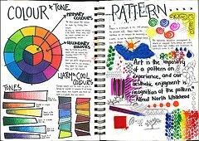

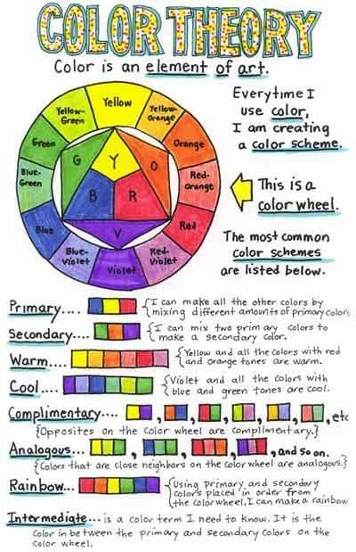

Well… Maybe you are thinking. I can’t draw. People told Pablo Picasso the same thing, and he became the Father of Modern Art. (one of the best artists ever!)

Well… maybe you are thinking, I don’t have time. Sketches can be 5minutes or less. You can continue to work or build on the same sketch or sketch page until it is full.

Well… maybe you are thinking, my sketch won’t look like these, or as good as another person. They don’t have to and are not supposed to look like anyone’s but yours. They will get better over time if you give your best effort. Maybe you have new and interesting twist on things.

Well… maybe you are thinking , I make a lot of mistakes. We learn from mistakes, and maybe those mistakes will solve a different problem or be used at another time.

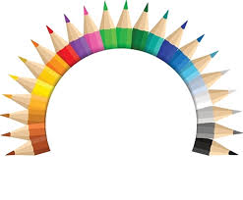

Above should have answered( a little it): What is a sketchbook, and Why do artists use one.

But, I bet you are still wondering;

**How do I know If I am doing good?**

That is personal,…. But simply put….

**Are you doing your best?**

If you are, then you are doing great! Keep drawing, practicing, being creative, and keep growing.

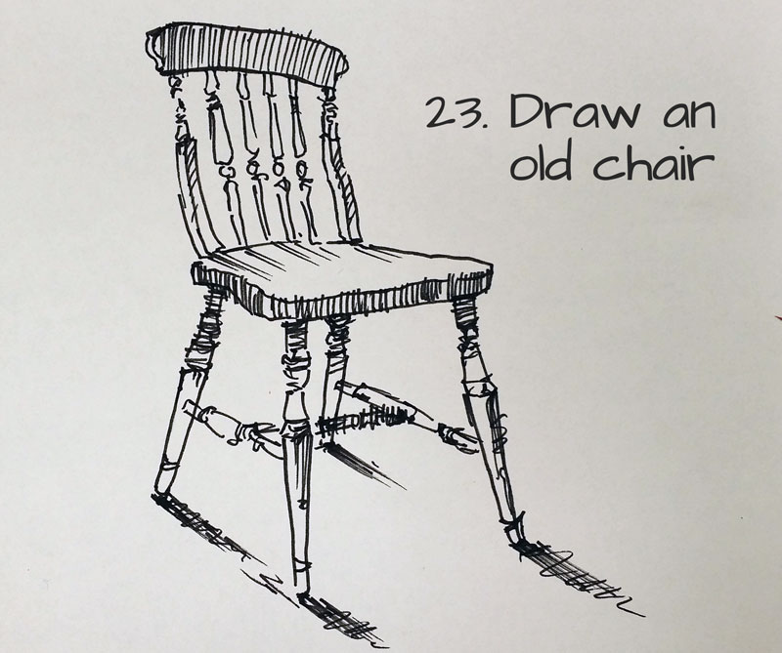 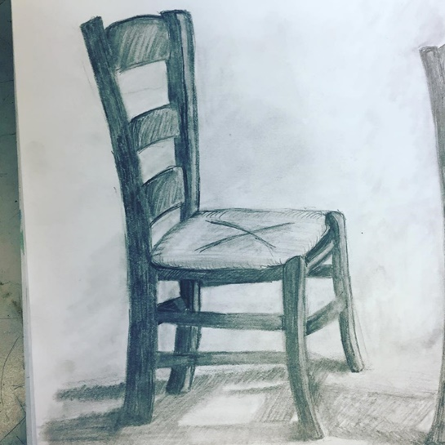

Rest easy!

**Enjoy your sketchbook.**

There is no Judgement there….like a diary.